SCHOOL OF COMPUTER SCIENCE AND ARTIFICIAL INTELLIGENCE |  |  |  |  | DEPARTMENT OF COMPUTER SCIENCE ENGINEERING
Program Name: B. Tech |  |  |  | Assignment Type: Lab |  |  | Academic Year:2025-2026
Course Coordinator Name |  |  |  | Venkataramana Veeramsetty
Instructor(s) Name |  |  |  | Dr. V. Venkataramana (Co-ordinator)  Dr. T. Sampath Kumar  Dr. Pramoda Patro  Dr. Brij Kishor Tiwari  Dr.J.Ravichander  Dr. Mohammand Ali Shaik  Dr. Anirodh Kumar  Mr. S.Naresh Kumar  Dr. RAJESH VELPULA  Mr. Kundhan Kumar  Ms. Ch.Rajitha  Mr. M Prakash  Mr. B.Raju  Intern 1 (Dharma teja)  Intern 2 (Sai Prasad)  Intern 3 (Sowmya)  NS_2 ( Mounika)
Course Code |  |  | 24CS002PC215 | Course Title |  | AI Assisted Coding
Year/Sem |  |  | II/I | Regulation |  | R24
Date and Day  of Assignment |  |  | Week11 - Monday | Time(s)
Duration |  |  | 2 Hours | Applicable to  Batches
AssignmentNumber:21.1(Present assignment number)/24(Total number of assignments)
 | Q.No. | Question |  |  |  |  |  | Expected Time  to complete
 | 1 | Lab 21 – Collaborative AI Coding: Pair Programming and Version Control Integration  Lab Objectives:  - Learn to use AI as a pair programmer for writing, reviewing, and optimizing code.  - Understand how to integrate AI-generated code into version control systems (Git).  - Practice collaborative workflows such as commit messages, branching, and merging.  Task 1 – AI-Assisted Pair Programming  - Use AI to generate an initial program (e.g., a simple To-Do List Manager).  - Ask AI to suggest enhancements (such as error handling, additional features, or refactoring).  - Compare the original and improved versions to understand the role of AI in collaboration.  Prompt:  - Use AI to generate and enhance a dynamic input To-Do List program by adding validation, error handling, and prioritization, then compare the original and improved versions to analyze AI’s collaborative role.  Code:  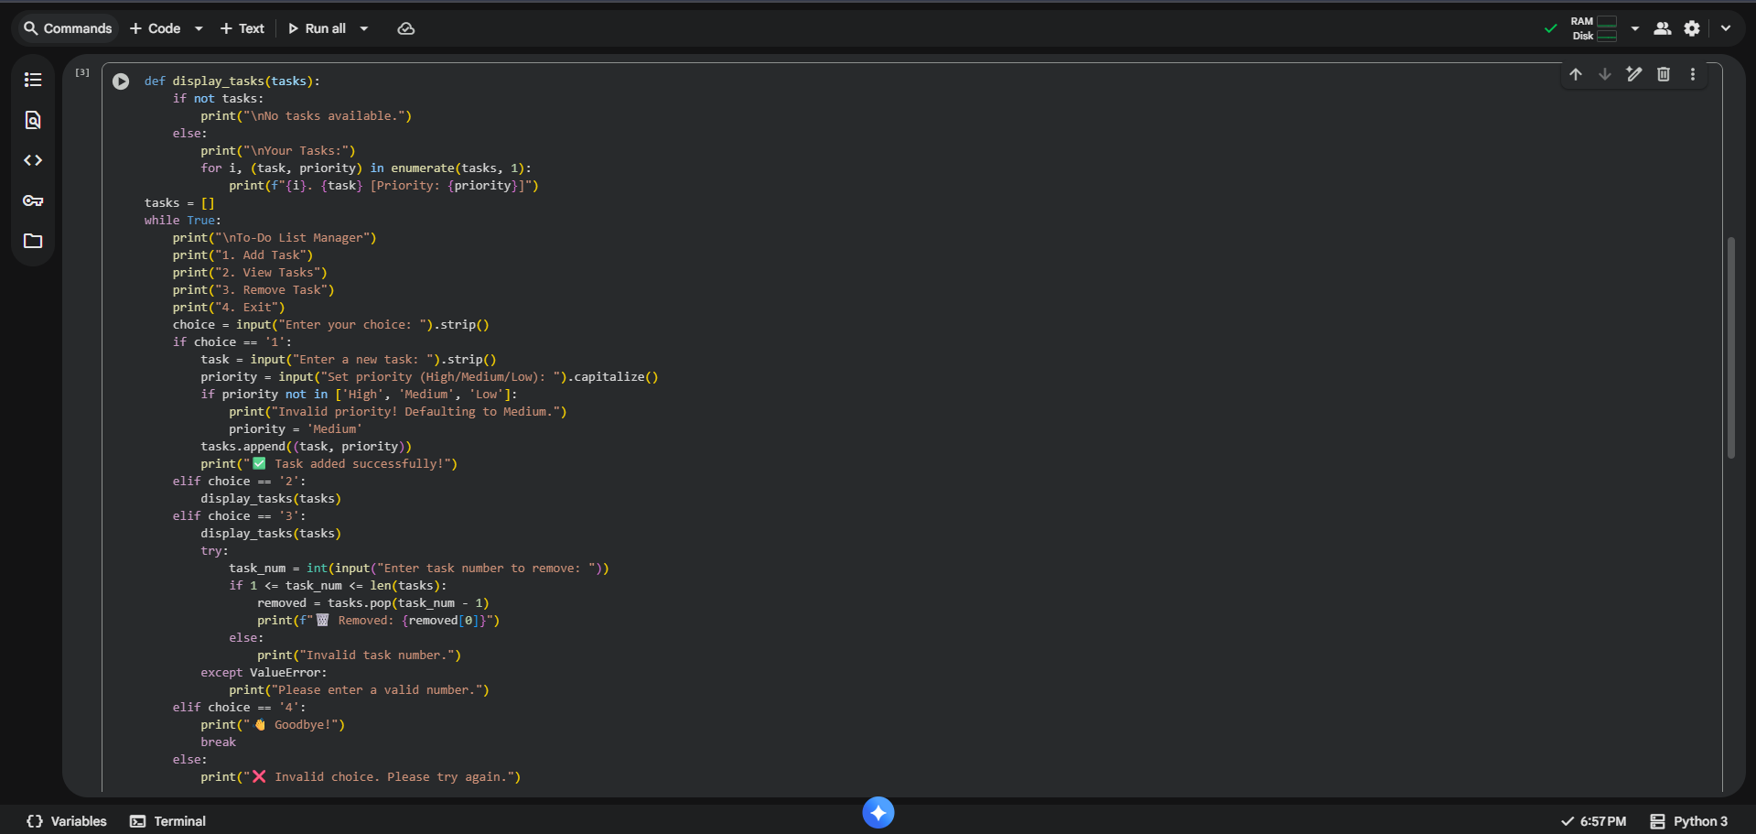  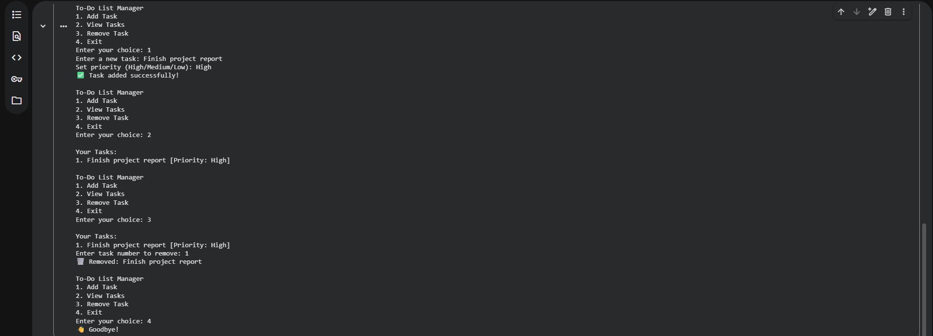  Observation:  - This Flask application implements a secure user login endpoint that verifies credentials against an SQLite database. It utilizes bcrypt for secure password comparison and parameterized queries to prevent SQL injection vulnerabilities.  Task 2 – Version Control Integration  - Initialize a Git repository for your project.  - Perform the following steps:  - Create and switch to a new branch.  - Add AI-assisted modifications.  - Commit with a meaningful message.  - Merge changes back into the main branch.  - Reflect on how version control supports collaborative development with AI assistance.  Prompt:  - Use AI to generate a dynamic input program (e.g., a calculator or task manager), then integrate Git by creating a new branch, adding AI-assisted code improvements, committing with clear messages, and merging changes to demonstrate how version control enhances AI-supported collaboration.  Code:  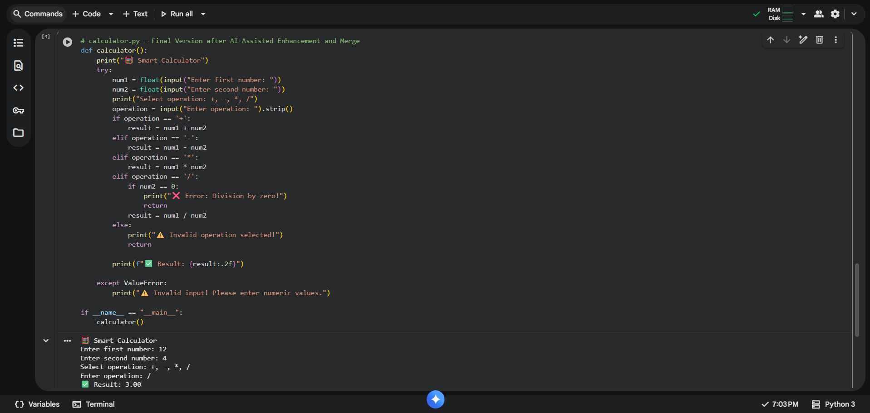  Observation:  - This Flask application sets up a secure login route /login using bcrypt to safely verify user passwords against an SQLite database. It prevents SQL injection vulnerabilities by employing parameterized queries for database interactions.  Task 3 – AI for Commit Message Generation  - Use AI to generate concise, meaningful commit messages based on the changes made.  - Compare AI-generated messages with human-written ones.  - Discuss how AI can improve documentation and traceability in Git history.  Prompt:  - Use AI to generate concise commit messages for a dynamic input program (e.g., temperature converter), compare them with human-written ones, and discuss how AI enhances documentation and traceability in Git history.  Code:  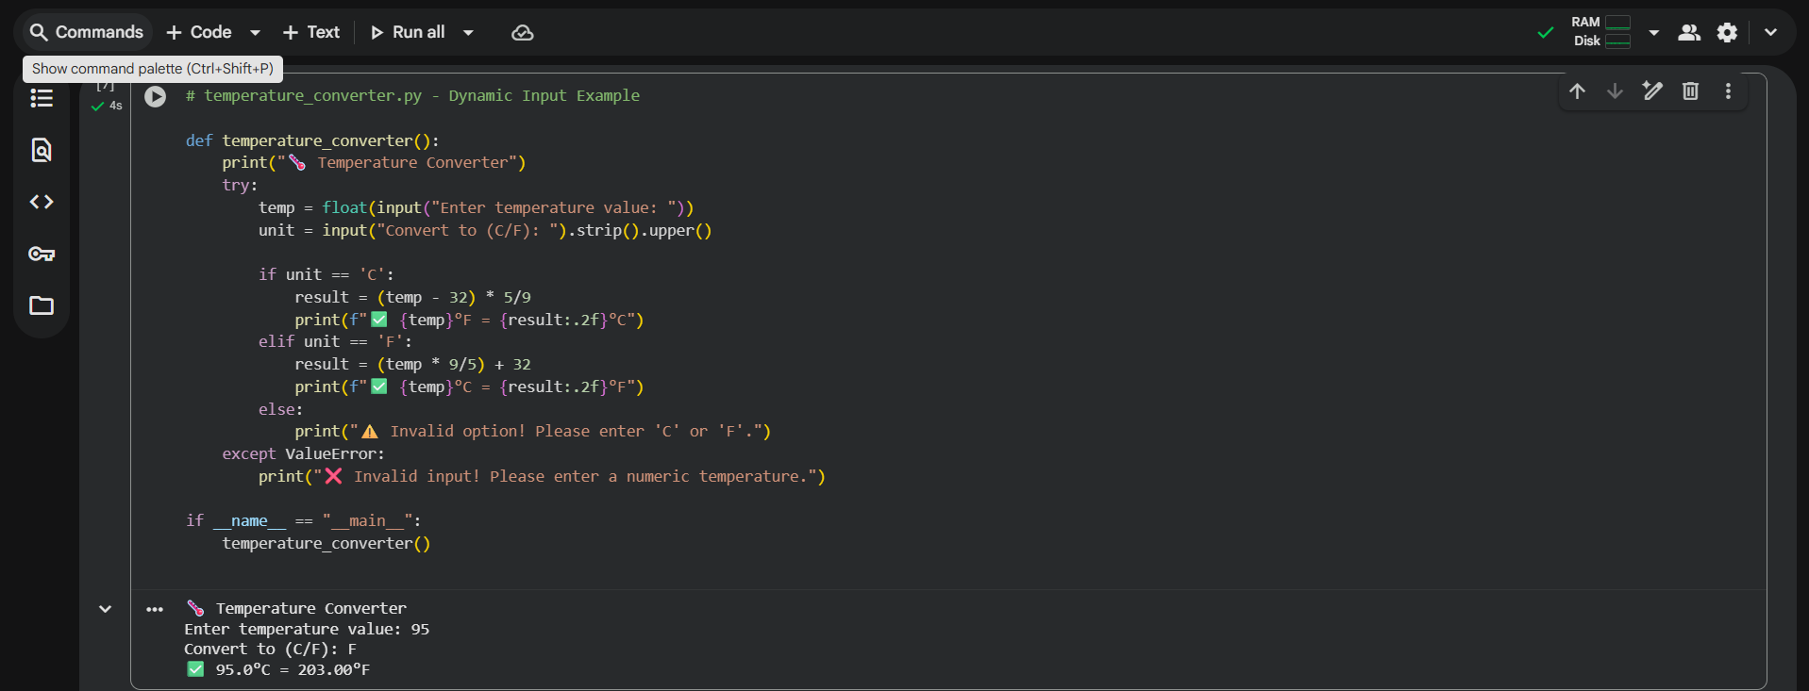  Observation:  - This code implements a basic Flask web application featuring a /login endpoint to authenticate users. It securely verifies passwords using bcrypt and connects to an SQLite database, employing parameterized queries to prevent SQL injection.  Task 4 – Pair Programming Simulation  - Student A writes the initial version of a program.  - Student B, with AI assistance, suggests improvements or adds features.  - Both students collaborate using Git branching and merging to integrate their work.  ✅ Deliverables (For All Tasks)  - AI-generated prompts for code and test case generation.  - At least 3 assert test cases for each task.  - AI-generated initial code and execution screenshots.  - Analysis of whether code passes all tests.  - Improved final version with inline comments and explanation.  - Compiled report (Word/PDF) with prompts, test cases, assertions, code, and output.  Prompt:  - Use AI in a pair programming setup where one student writes a basic grade calculator and another, with AI assistance, enhances it to handle multiple students, input validation, and summary display demonstrating collaborative coding with Git integration.  Code:  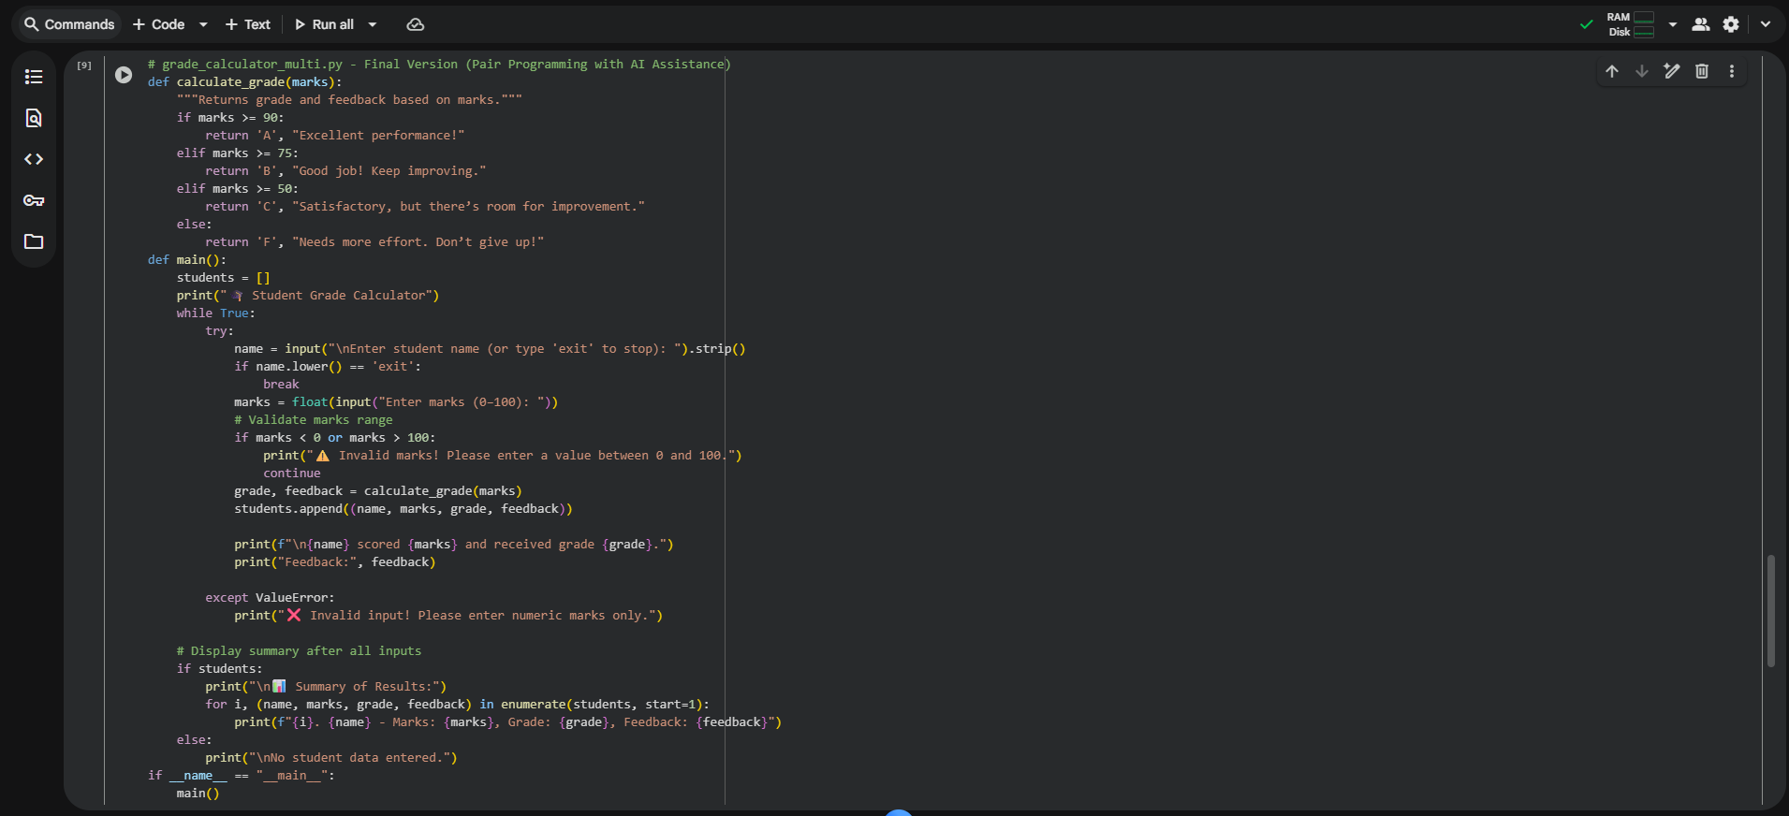  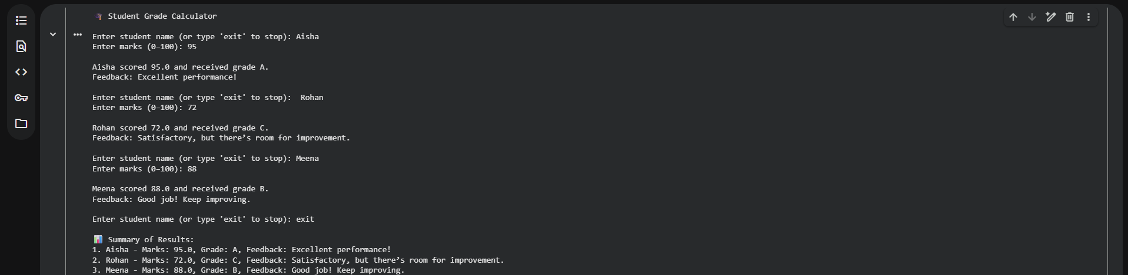  Observation:  - This Python code creates a Flask web service with a /login route that securely authenticates users. It utilizes bcrypt for password hashing and sqlite3 for database interaction, crucially preventing SQL injection with parameterized queries. |  |  |  |  |  | Week11 - Monday

